UML CLASS DIAGRAMS – 1

1.LIBRARY MANAGEMENT SYSTEM

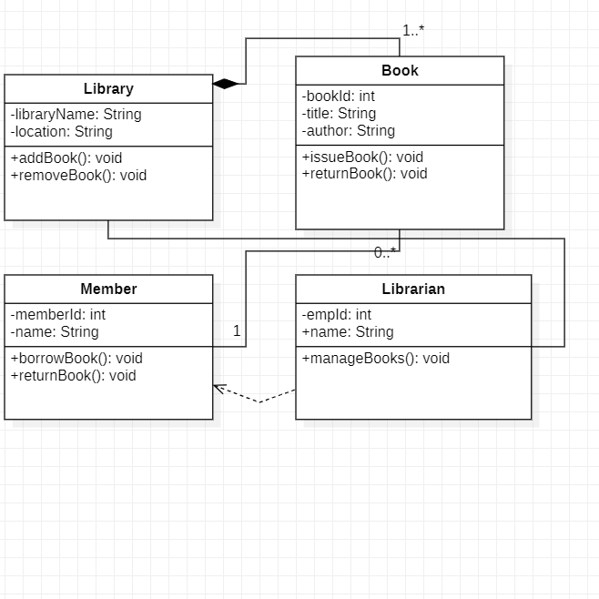

2.ATM CLASS DIAGRAM

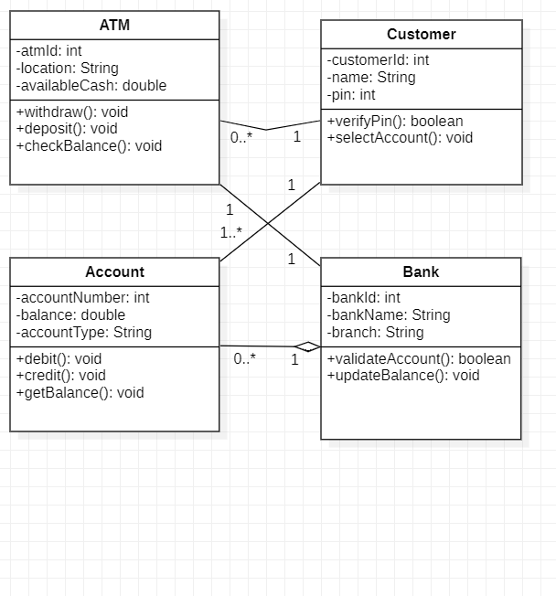

3.BILLING

